Dokumentasi Software Architecture Lab Project - WSpeedRun.com
- Joseline Fransiska Wijaya (2802455722)
- Kelly Aurelya Tiona (2802455325)
- Michelle Santoso (2802452582)

- Role Pengguna
- Guest
- Melihat User Profile berdasarkan UserID
- Melihat daftar keseluruhan game
- Melihat detail dari sebuah game dengan kategorinya
- Melihat detail dari sebuah kategori berdasarkan RunCategoryID
- Melihat leaderboard
- Hanya dapat melihat detail run dengan status ACCEPTED
- Melihat detail dari sebuah speedrun berdasarkan RunID

- User
- Melakukan register dan login
- Mengirim submit speedrun
- Melihat keseluruhan riwayat run milik sendiri
- Mengirim dan menghapus komentar di sebuah run

- Admin
- Membuat game baru, mengubah detail game yang sudah ada, serta menghapus sebuah game
- Membuat kategori run, mengubah detail kategori yang sudah ada, serta menghapus sebuah kategori
- Melihat daftar speedrun berdasarkan status
- Menerima atau menolak speedrun berdasarkan RunID

- System Architecture
Sistem dibagi menjadi tiga service utama yang saling berkomunikasi menggunakan HTTP request.
Service Name | Port | Description
Auth Service | 3000 | Handles user registration, login, authentication (JWT generation), and profile-related operations.
Game Service | 3001 | Manages game and run category data, including creating, updating, deleting, and retrieving game information.
Run Service | 3002 | Handles speedrun submissions, verification processes (accept or reject), leaderboard data, and run-related comments.

- Environment Variables
PORT=3000
DATABASE_URL="mysql://root:@localhost:3306/wspeedrun_db"
JWT_SECRET="Super_Secret_SoftArch"

AUTH_SERVICE_URL=http://localhost:3000
GAME_SERVICE_URL=http://localhost:3001
RUN_SERVICE_URL=http://localhost:3002

- How to Run the Project
- Download the Project
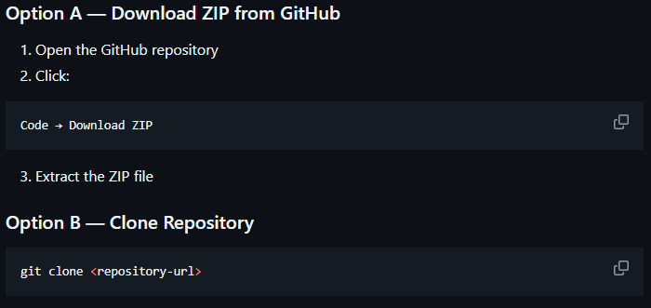

- Open Project
Open the extracted project folder using Visual Studio Code.

- Install Dependencies
Each service must install dependencies separately.
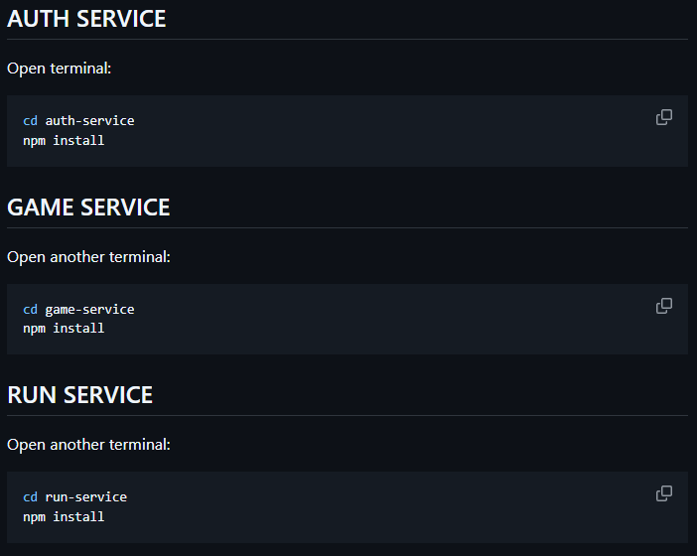

- Setup Environment Variables
Create a `.env` file inside EACH service folder.
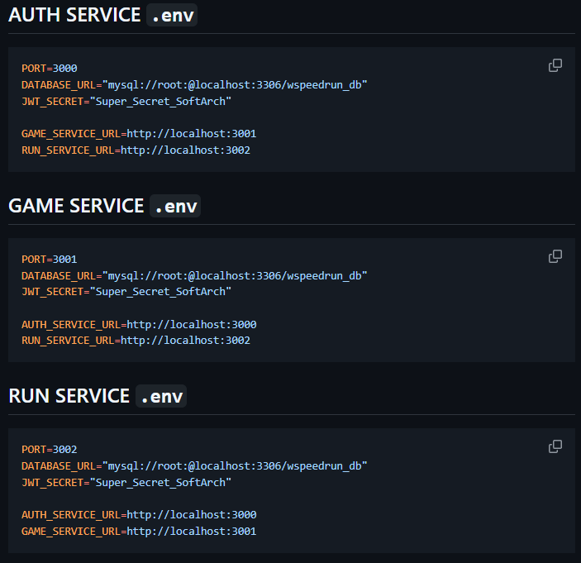

- Setup Database
Create the MySQL database:

CREATE DATABASE wspeedrun_db;

Import the provided SQL file into the database.
Example using MySQL CLI: mysql -u root -p wspeedrun_db < database/clean.sql
After importing the SQL file, generate Prisma Client inside EACH service folder.

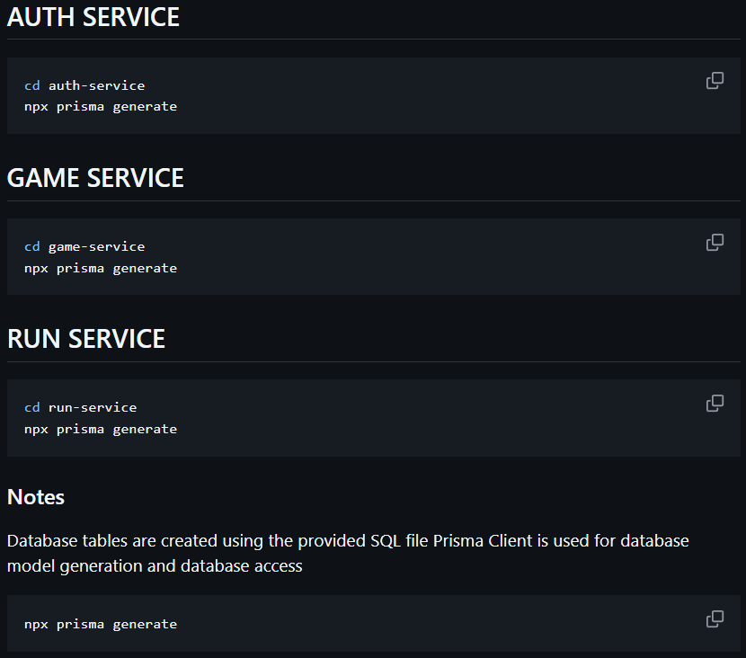

- Run the Services
Each service must run in separate terminals.
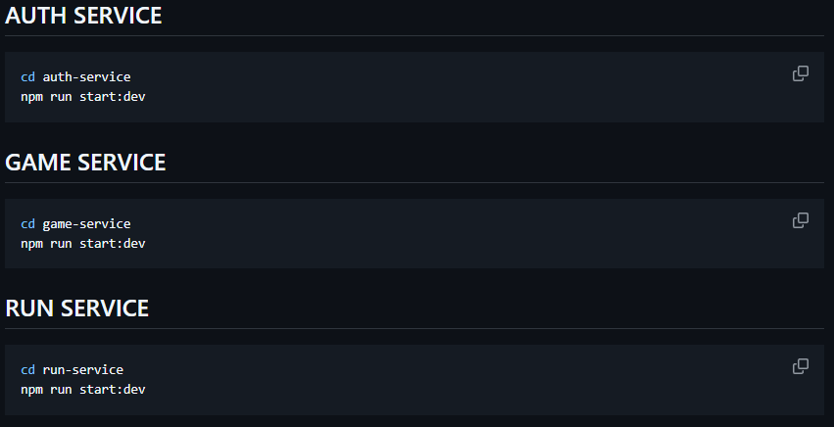

- Authentication dan Authorization
Authentication menggunakan JWT (JSON Web Token). User akan mendapatkan token setelah berhasil login.
- AuthGuard digunakan untuk endpoint user
- AdminGuard digunakan untuk endpoint admin
- JWT disimpan menggunakan environment variable

- Endpoint
Method Endpoint | Role | Deskripsi
- POST/auth/register | Guest | Register akun
- POST/auth/login | Guest | Login akun untuk mendapatkan JWT Token
- GET/users/:id/profile | Guest | Melihat User Profile berdasarkan UserID
- GET/games | Guest | Melihat daftar keseluruhan game
- GET/games/:id | Guest | Melihat detail dari sebuah game dengan kategorinya berdasarkan GameID
- POST/admin/games | Admin | Membuat game baru
- PATCH/admin/games/:id/update | Admin | Mengubah detail game yang sudah ada berdasarkan GameID
- DELETE/admin/games/:id/delete | Admin | Menghapus sebuah game berdasarkan GameID
- GET/categories/:id | Guest | Melihat detail dari sebuah kategori berdasarkan RunCategoryID
- POST/admin/categories | Admin | Membuat kategori run
- PATCH/admin/categories/:id/update | Admin | Mengubah detail kategori yang sudah ada berdasarkan RunCategoryID
- DELETE/admin/categories/:id/delete | Admin | Menghapus sebuah kategori berdasarkan RunCategoryID
- GET/runs/:id/category | Guest | Melihat leaderboard
- GET/runs/:id/user | Guest, User | Melihat speedrun yang pernah dilakukan User berdasarkan UserID.
- GET/runs/:id | Guest | Melihat detail dari sebuah run berdasarkan RunID
- POST/runs | User | Membuat speedrun baru
- GET/admin/runs/:status | Admin | Melihat daftar speedrun berdasarkan status
- POST/admin/runs/:id/accept | Admin | Menerima speedrun berdasarkan RunID
- POST/admin/runs/:id/reject | Admin | Menolak speedrun berdasarkan RunID
- POST/comments | User | Membuat komentar di sebuah speedrun
- DELETE/comments/:id | User | Menghapus komentar di sebuah speedrun berdasarkan CommentID

Testing
AUTH-SERVICE
- POST/auth/register
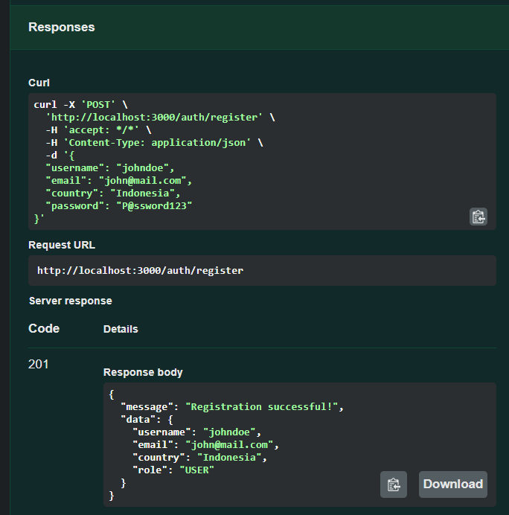
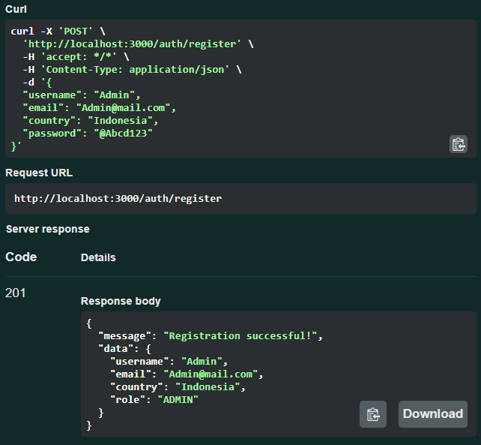

- POST/auth/login
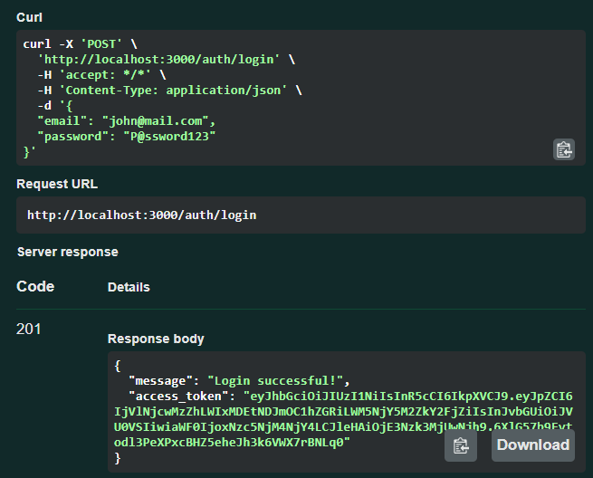
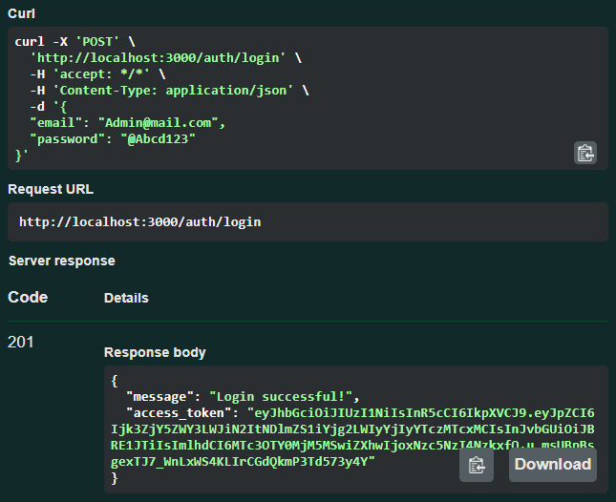

- GET/users/:id/profile
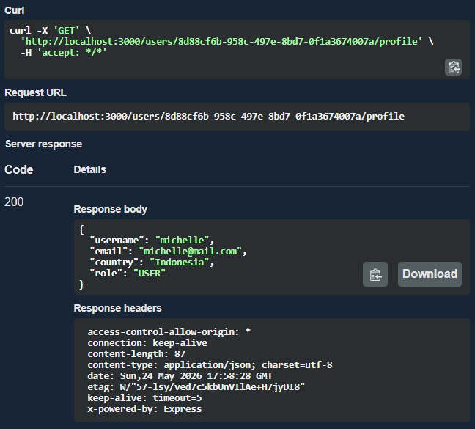

GAME-SERVICE
- GET/games
As a guest,
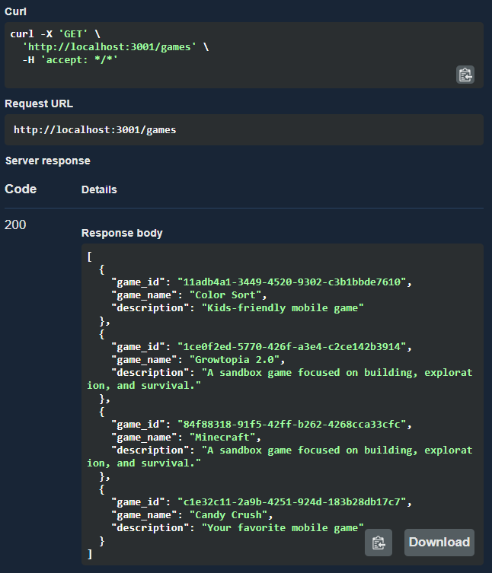

- GET/games/:id
As a guest,
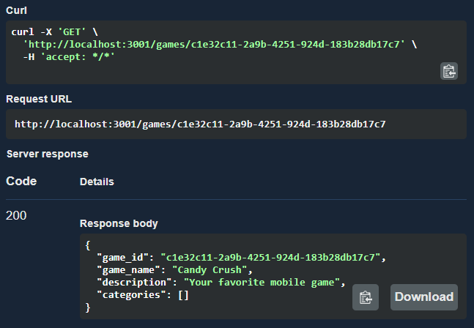
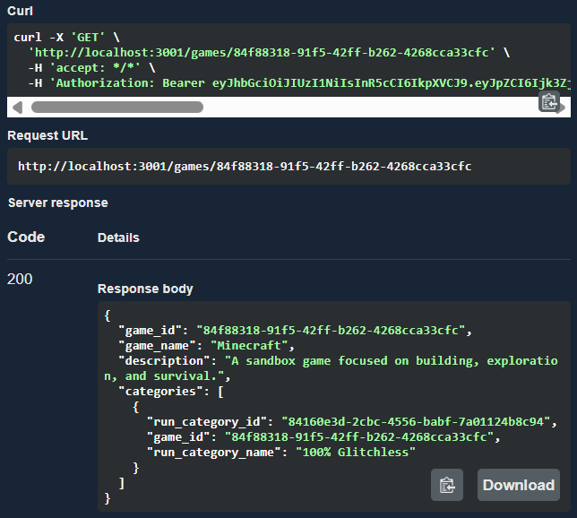

- POST/admin/games
As a guest,
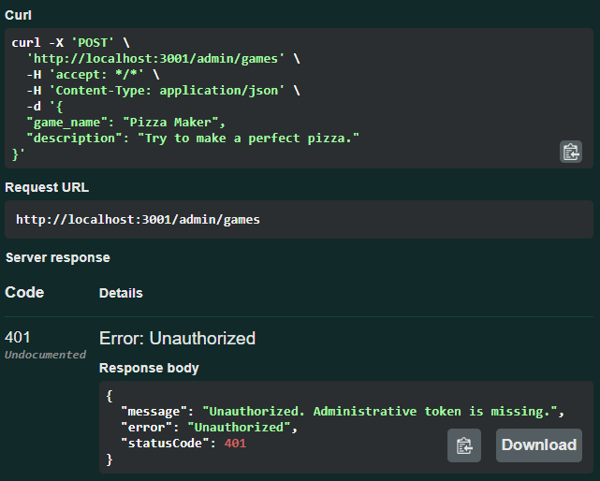

As an user,
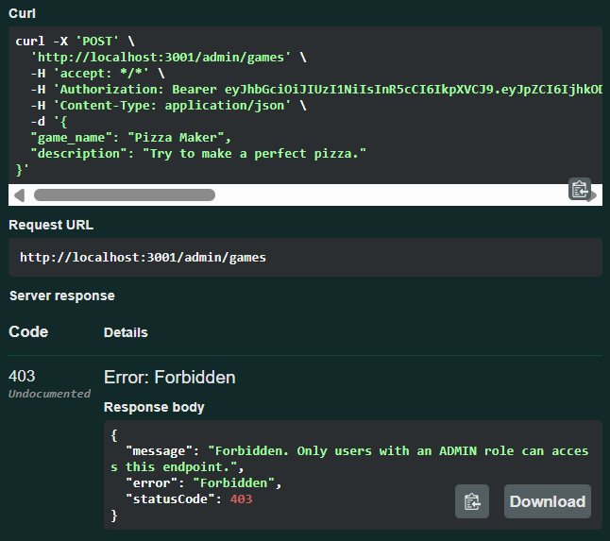

As an admin, 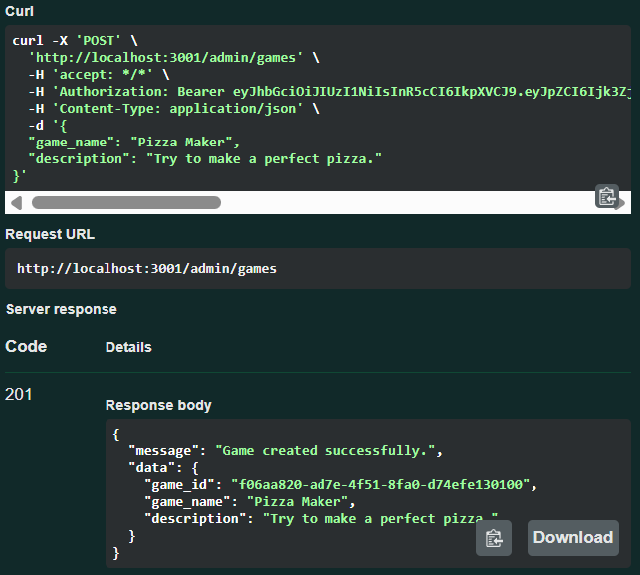

- PATCH/admin/games/:id/update
As an admin,
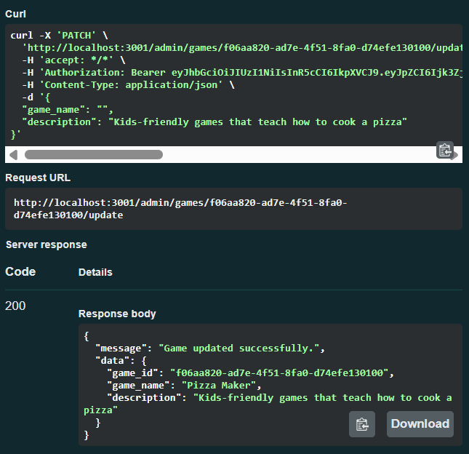

- DELETE/admin/games/:id/delete
As an admin,
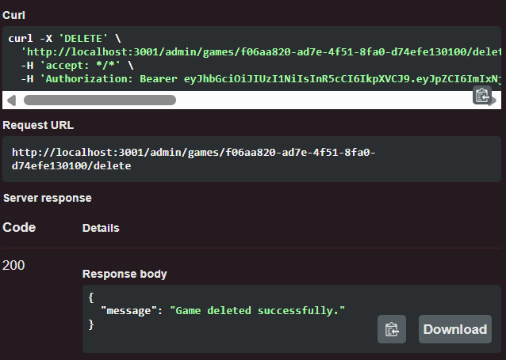

- GET/categories/:id
As a guest,
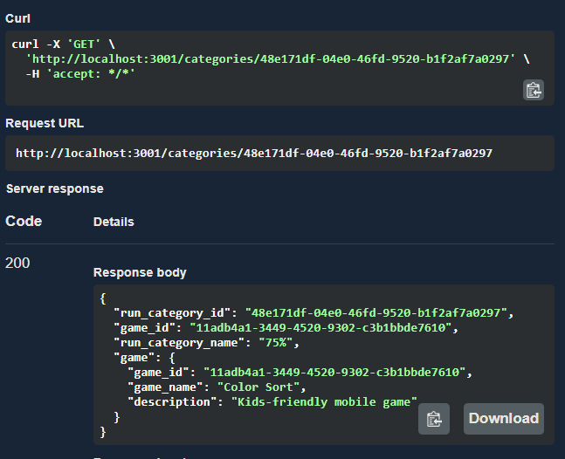

- POST/admin/categories
As an admin,
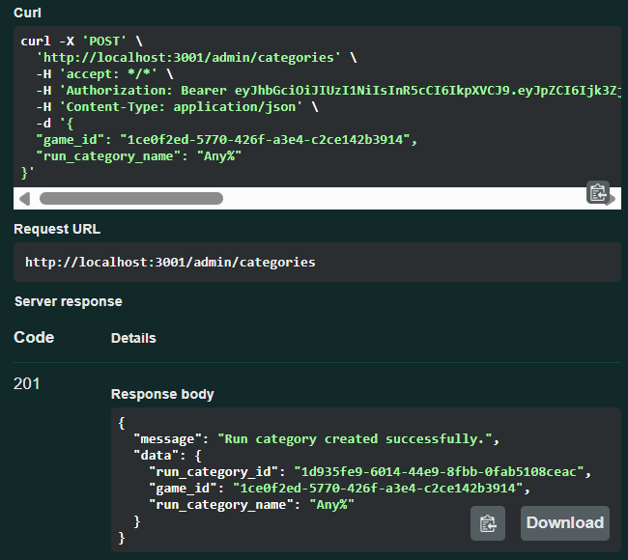

- PATCH/admin/categories/:id/update
As an admin,
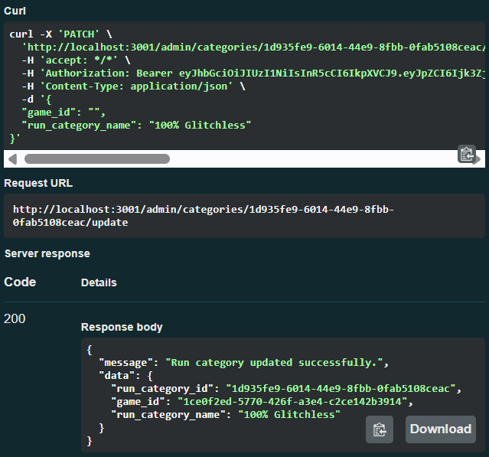

- DELETE/admin/categories/:id/delete
As an admin,
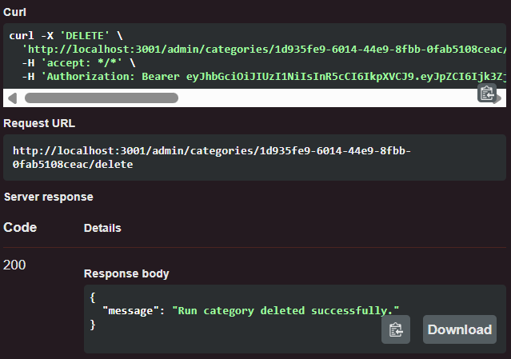

RUN-SERVICE
- GET/runs/:id/category
As a guest,
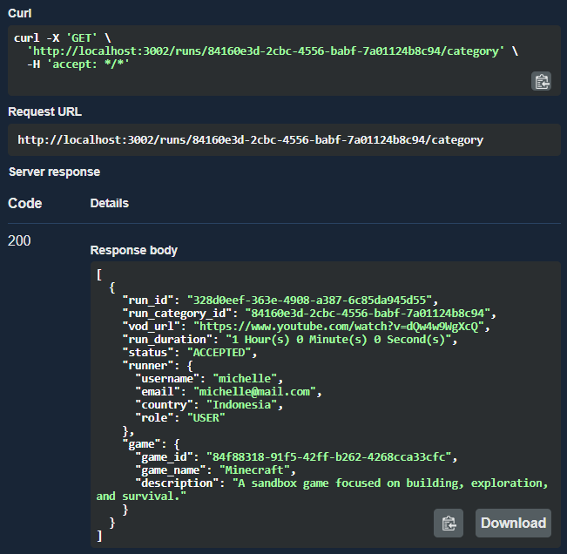

- GET/runs/:id/user
As a guest, only ACCEPTED run will be retrieved.
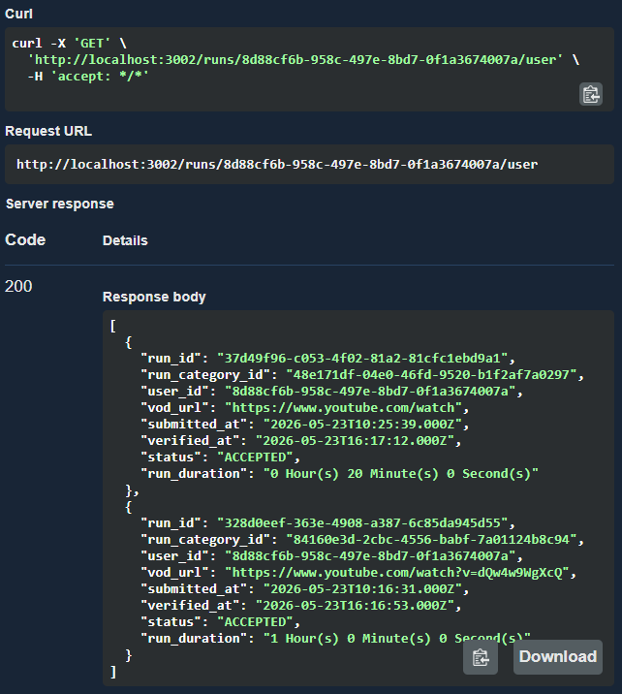

As an authenticated user, all runs are returned. 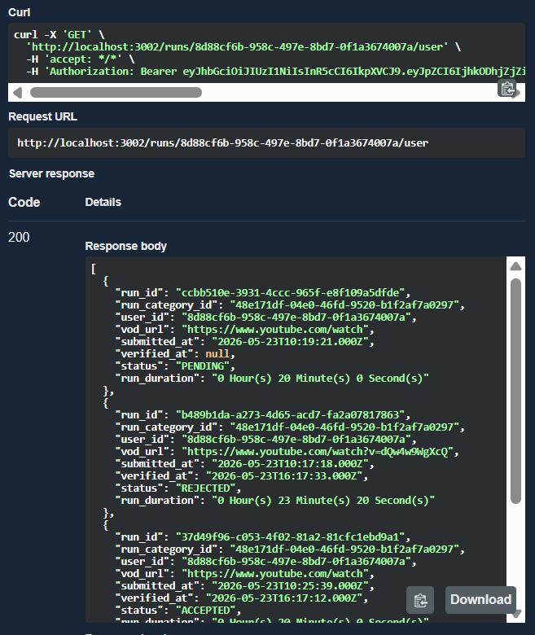

- GET/runs/:id
As a guest,
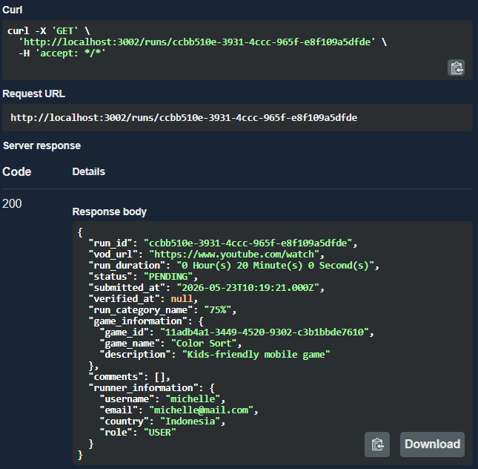

- POST/runs
As a guest,
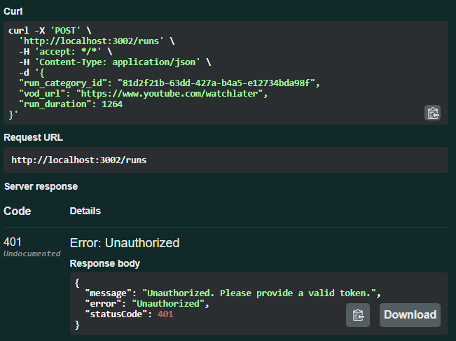

As an user,
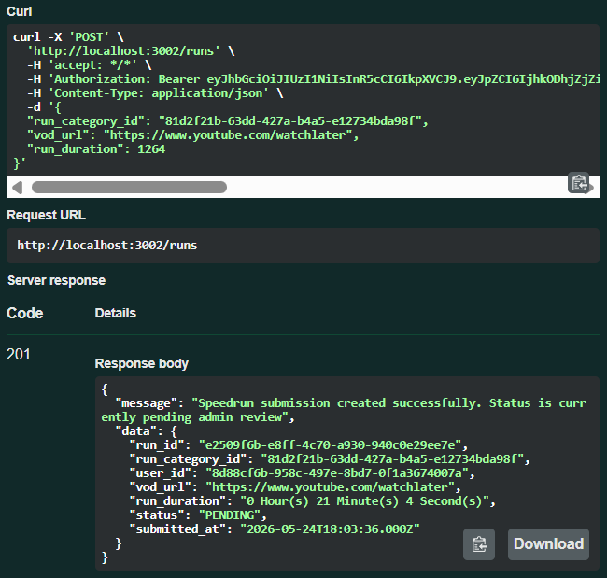

- GET/admin/runs/:status
As an user,
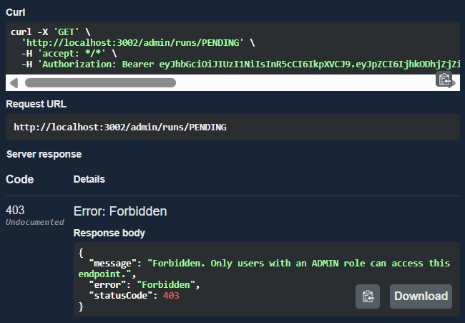

As an admin, input : PENDING
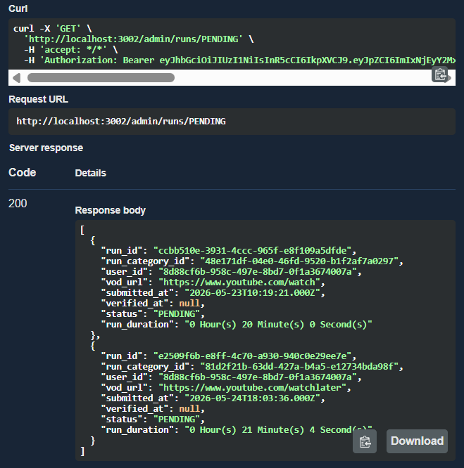

As an admin, input : ACCEPTED
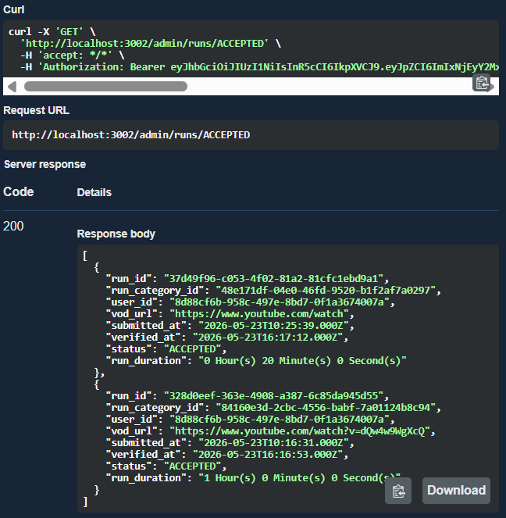

As an admin, input : REJECTED
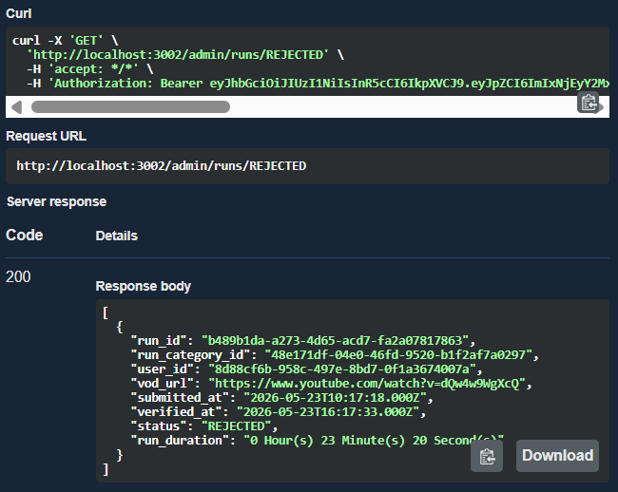

- POST/admin/runs/:id/accept
As an admin, if the status isn’t PENDING
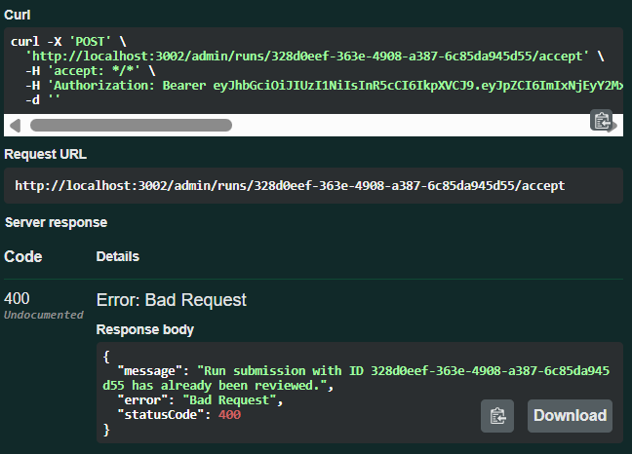

As an admin, if the status is PENDING
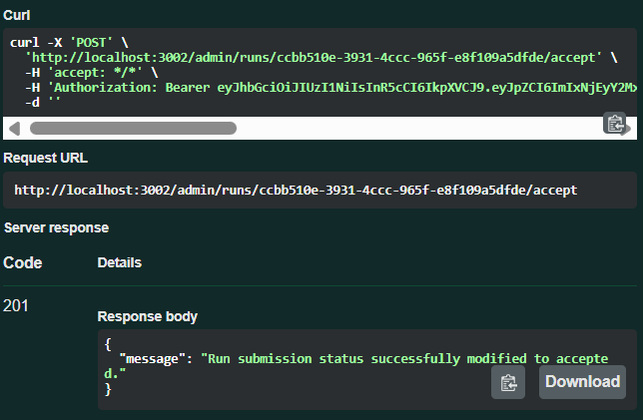

- POST/admin/runs/:id/reject
As an admin, if the status isn’t PENDING
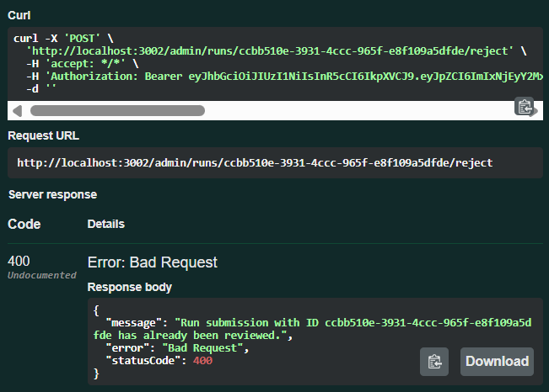

As an admin, if the status is PENDING
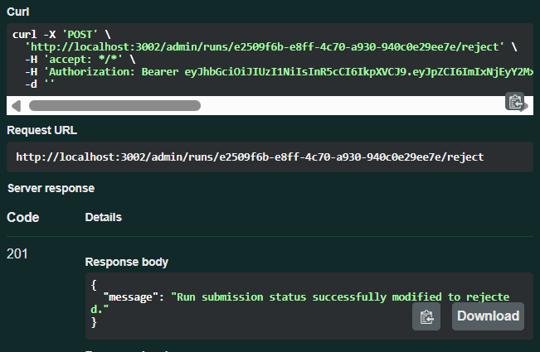
- POST/comments
As a guest,
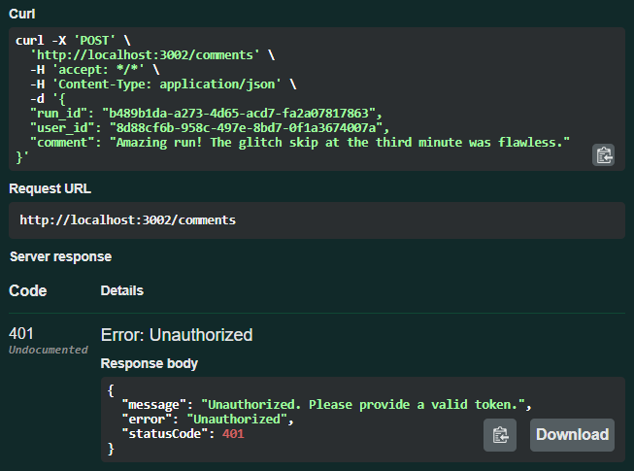

As an user,
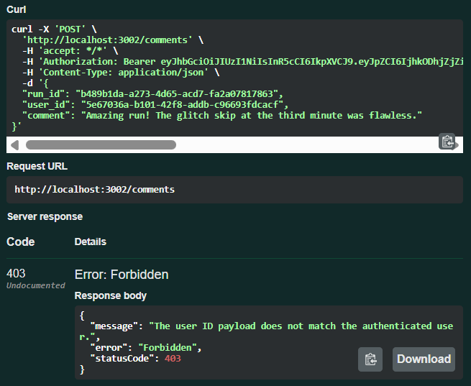

As an authenticated user,
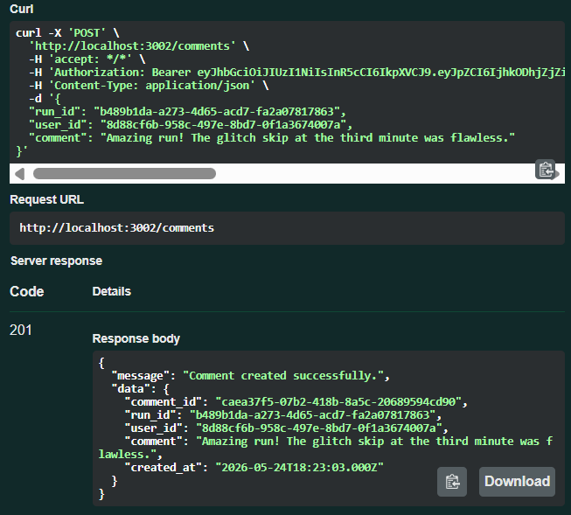

- DELETE/comments/:id
As an user,
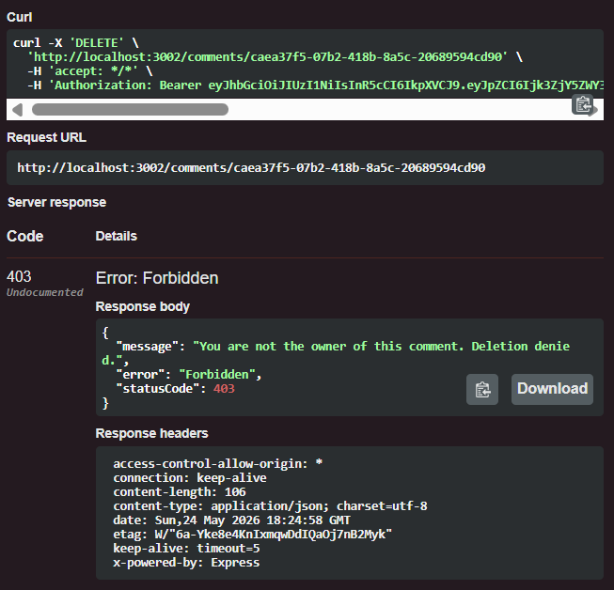

As an authenticated user,
